NAAN MUDHALVAN PROJECT

Topic: Impact of Apple Iphone in India.

Team:

1. G.S. KANIMOZHI

2. S. INDUMATHI

3.S. PRIYA DHARSHINI

4. S. NIVETHA

Overview:

Introduction:

The world has changed as a consequence of the increasing use of smartphones, which have improved communication, connected people, and revolutionized many different businesses. With its main product, the iPhone, capturing markets around the world, Apple Inc. has emerged as a prominent player among the top smartphone makers. India, one of the economies with the greatest economic growth, has seen a tremendous increase in smartphone usage, making it an interesting market to study the effects of Apple's iPhone.

Purpose:

* The fastest phone you can ever use, with a powerful processor and regular operating system updates.
* A smooth and easy user interface, with a continuity feature that allows you to switch between devices seamlessly.
* A family sharing option that lets you share apps, music, photos, and more with your family members.
* A secure and reliable device, with fewer security breaches and the best help and support available on the market.

Problem definition and design thinking :

Empathy:

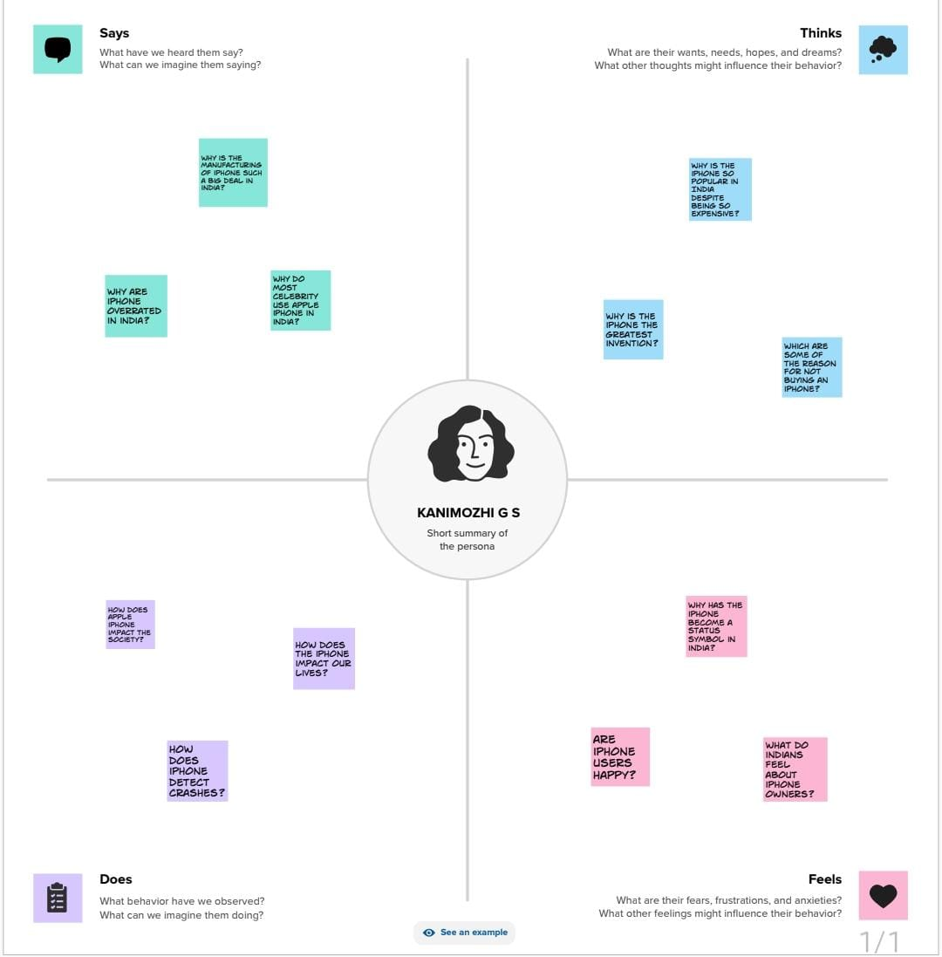

Brainstorm:

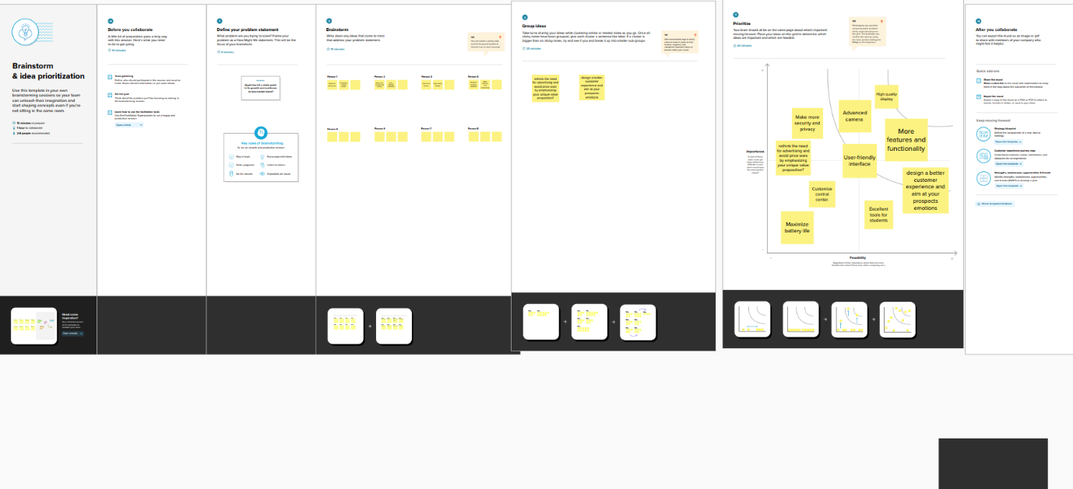

Result:

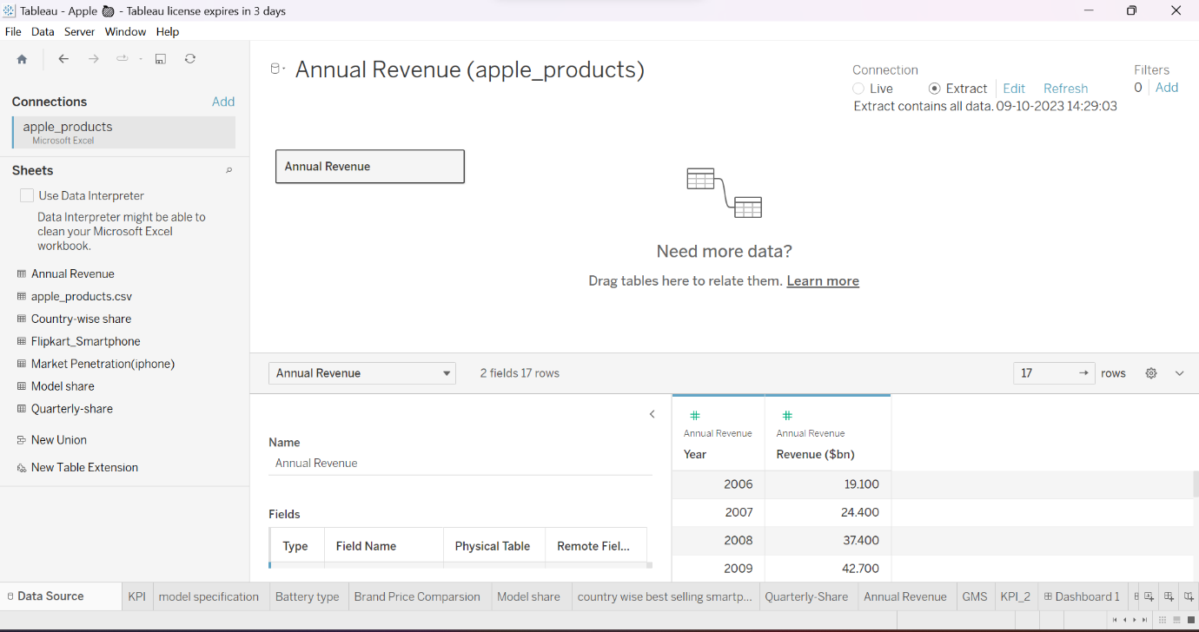

Advantages:

1. **iPhone is user-friendly**
2. **High quality display.**
3. **Advanced camera**
4. **More security.**

Disadvantages:

1.cost

2.non removable battery

3. limited customization

Application:

Uses:

IPhones have a simple interface and the similarity of the UI between the apple devices make it really easy to operate. The iPhone ensures all apps and functions are being performed the way Apple intends them to which allows for simple user experience. While android has more freedom and choices, users find it comparatively difficult to use.

Importance:

This is the first most concrete benefit of having an iPhone. Even though companies are trying hard to produce the best phones to date, yet iPhone carves a good reputation for itself by being the most user-friendly phone till this date. The interesting thing about the iPhone is the look and texture of iOS hasn't changed even today. It is exactly the way it was launched in 2008. The only thing you need to do it to pick up the phone and touch the app icon. iPhone is also easy to learn and navigate.

Conclusion:

The main conclusion that can be drawn is  we found to be the most interesting about Apple is how they are very innovative and early adapters. Apple is usually the first company to come out with a new product line before anyone else. This is very risky but it seems to be working to Apples advantage. This shows that taking risks can sometimes make or break you and Apple has great potential and has a lot to improve. Currently, Apple is demonstrating negative aspects of TNCs, contributing to international debt crisis through exploitation of workers.

Future scope:

From the camera quality to advancements of technology networks, we’ve seen the iPhone incorporate a number of changes since its launch in 2007. However, perhaps the most noticeable change we’ve seen has been its size increase. While the first iPhone in 2007 had a screen size of just 3.5-inches, the recently announced iPhone 12 Pro Max is almost double the size at 6.7-inches. In total, that equates to a 91 per cent increase and an average growth of 5 per cent year-on-year. The graphic below shows how the iPhone has grown over the last 13 years. Despite it starting out only slightly bigger than a credit card, if it continues to grow at its current rate the iPhone will be bigger than an Apple Mac keyboard by 2040. With a display size of 17.5-inches it will also be taller than a bottle of wine.